Kuberenets Quota

**Namespace creation**

[root@k-master yamls]# kubectl create namespace quota-demo-ns

namespace/quota-demo-ns created

[root@k-master yamls]# kubectl get ns

NAME STATUS AGE

default Active 13m

kube-node-lease Active 13m

kube-public Active 13m

kube-system Active 13m

quota-demo-ns Active 4s

[root@k-master yamls]# kubectl create -f 7-quota-count.yaml

resourcequota/quota-demo1 created

[root@k-master yamls]# kubectl get quota -n quota-demo-ns

NAME AGE REQUEST LIMIT

quota-demo1 44s configmaps: 0/1, pods: 0/2

[root@k-master yamls]#

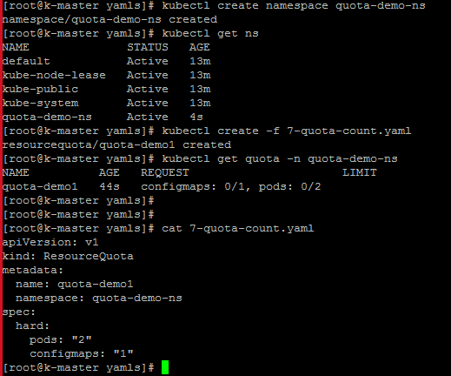

[root@k-master yamls]# **kubectl describe quota -n quota-demo**-ns

Name: quota-demo1

Namespace: quota-demo-ns

Resource Used Hard

-------- ---- ----

configmaps 0 1

pods 0 2

[root@k-master yamls]

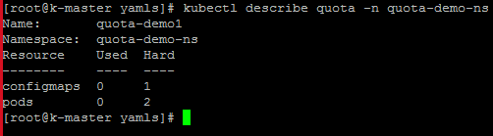

Create config map

[root@k-master yamls]# kubectl -n quota-demo-ns create configmap cm1 --from-literal=name=venkat

configmap/cm1 created

[root@k-master yamls]# kubectl -n quota-demo-ns get cm

NAME DATA AGE

cm1 1 68s

[root@k-master yamls]#



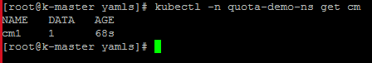

kubectl -n quota-demo-ns describe quota quota-demo1

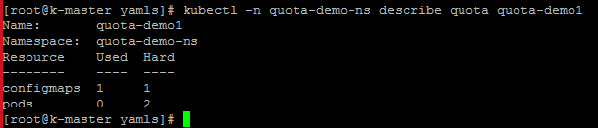

kubectl -n quota-demo-ns create configmap cm2 --from-literal=name=venkat

(as we have quota set to create only 1 config, so cant create more than 1)



Cm2 config map is not exit,so thrown eror

[root@k-master yamls]# kubectl -n quota-demo-ns delete configmap cm1 cm2

configmap "cm1" deleted

Error from server (NotFound): configmaps "cm2" not found

[root@k-master yamls]# kubectl -n quota-demo-ns get configmap

No resources found in quota-demo-ns namespace.

[root@k-master yamls]#

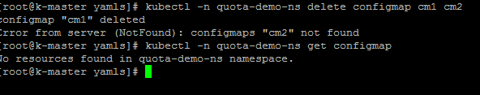

Create pod

[root@k-master yamls]# kubectl -n quota-demo-ns run nginx --image=nginx --replicas=1

Flag --replicas has been deprecated, has no effect and will be removed in the future.

pod/nginx created

[root@k-master yamls]# kubectl -n quota-demo-ns describe quota quota-demo1

Name: quota-demo1

Namespace: quota-demo-ns

Resource Used Hard

-------- ---- ----

configmaps 0 1

pods 1 2

[root@k-master yamls]#

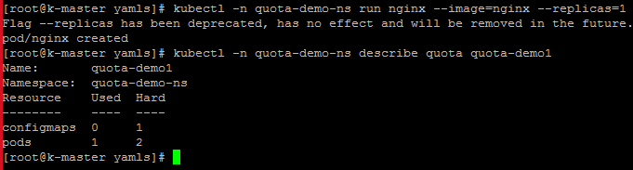

[root@k-master yamls]# kubectl -n quota-demo-ns get quota

NAME AGE REQUEST LIMIT

quota-demo1 28m configmaps: 0/1, pods: 1/2

[root@k-master yamls]# kubectl -n quota-demo-ns describe quota quota-demo1

Name: quota-demo1

Namespace: quota-demo-ns

Resource Used Hard

-------- ---- ----

configmaps 0 1

pods 1 2

[root@k-master yamls]# kubectl -n quota-demo-ns run nginx2 --image=nginx

pod/nginx2 created

[root@k-master yamls]# kubectl -n quota-demo-ns describe quota quota-demo1

Name: quota-demo1

Namespace: quota-demo-ns

Resource Used Hard

-------- ---- ----

configmaps 0 1

pods 2 2

[root@k-master yamls]# kubectl -n quota-demo-ns run nginx3 --image=nginx

Error from server (Forbidden): pods "nginx3" is forbidden: exceeded quota: quota-demo1, requested: pods=1, used: pods=2, limited: pods=2

[root@k-master yamls]#

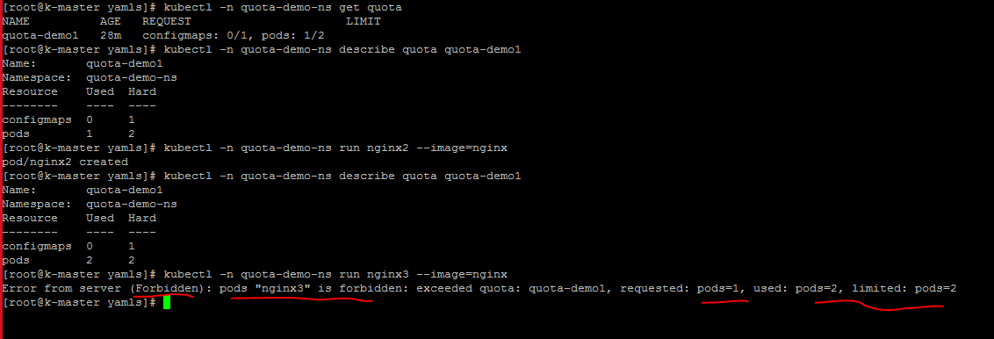

Removing existing pods and quota

[root@k-master yamls]# kubectl -n quota-demo-ns delete pods --all

pod "nginx" deleted

pod "nginx2" deleted

^L[root@k-master yamls]#

[root@k-master yamls]# kubectl -n quota-demo-ns delete pods --all

No resources found

[root@k-master yamls]#

[root@k-master yamls]# kubectl delete ns quota-demo-ns

namespace "quota-demo-ns" deleted

[root@k-master yamls]#

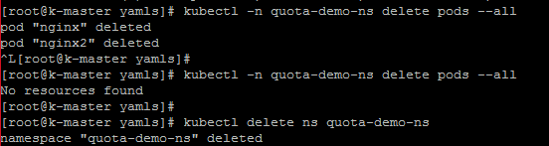

To restrict memory

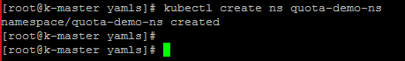

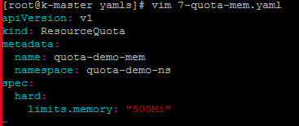

kubectl create -f 7-pod-quota-mem.yaml

[root@k-master yamls]# kubectl create -f 7-quota-mem.yaml

resourcequota/quota-demo-mem created

[root@k-master yamls]# kubectl get ns

NAME STATUS AGE

default Active 55m

kube-node-lease Active 55m

kube-public Active 55m

kube-system Active 55m

quota-demo-ns Active 5m59s

[root@k-master yamls]# kubectl -n quota-demo-ns describe quota quota-demo-mem

Name: quota-demo-mem

Namespace: quota-demo-ns

Resource Used Hard

-------- ---- ----

limits.memory 0 500Mi

[root@k-master yamls]#

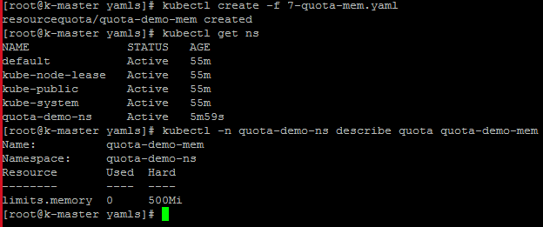

**(before creating the pod, you must have to define memory as quota is enabled for mentioned namespace)**

[root@k-master yamls]# vim 7-pod-quota-mem.yaml

apiVersion: v1

kind: Pod

metadata:

name: nginx

namespace: quota-demo-ns

spec:

containers:

- image: nginx

name: nginx

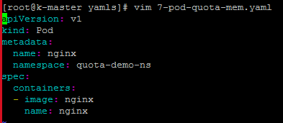

kubectl create -f 7-pod-quota-mem.yaml



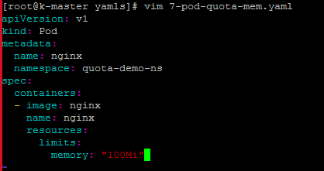

kubectl create -f 7-pod-quota-mem.yaml

kubectl -n quota-demo-ns describe quota quota-demo-mem

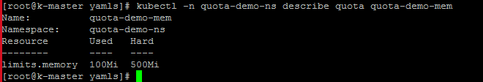

Here, we try to create pod with 800 Mi memory

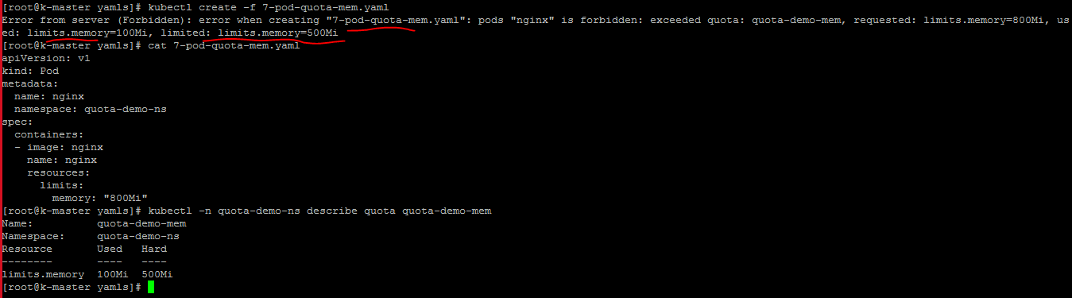

[root@k-master yamls]# kubectl create -f 7-pod-quota-mem.yaml

Error from server (Forbidden): error when creating "7-pod-quota-mem.yaml": pods "nginx" is forbidden: exceeded quota: quota-demo-mem, requested: limits.memory=800Mi, used: limits.memory=100Mi, limited: limits.memory=500Mi

[root@k-master yamls]# cat 7-pod-quota-mem.yaml

apiVersion: v1

kind: Pod

metadata:

name: nginx

namespace: quota-demo-ns

spec:

containers:

- image: nginx

name: nginx

resources:

limits:

memory: "800Mi"

[root@k-master yamls]# kubectl -n quota-demo-ns describe quota quota-demo-mem

Name: quota-demo-mem

Namespace: quota-demo-ns

Resource Used Hard

-------- ---- ----

limits.memory 100Mi 500Mi

[root@k-master yamls]#

**Limit Range**

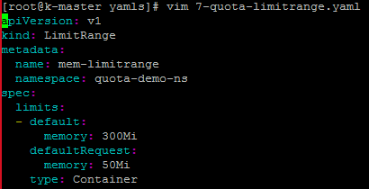

[root@k-master yamls]# vim 7-quota-limitrange.yaml

apiVersion: v1

kind: LimitRange

metadata:

name: mem-limitrange

namespace: quota-demo-ns

spec:

limits:

- default:

memory: 300Mi

defaultRequest:

memory: 50Mi

type: Container

[root@k-master yamls]# kubectl -n quota-demo-ns describe limitrange mem-limitrange

Name: mem-limitrange

Namespace: quota-demo-ns

Type Resource Min Max Default Request Default Limit Max Limit/Request Ratio

---- -------- --- --- --------------- ------------- -----------------------

Container memory - - 50Mi 300Mi -

[root@k-master yamls]#

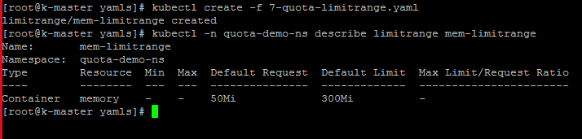

We have completed the video till 24:42